Software architecture document

Project MultichoiceTestMaker

**University of Engineering and Technology - VNU**

Team 1 – Class Software Engineering (INT2208 1)

Members:

1. Nguyen Thanh Ngan

2. Nguyen Duc Minh

3. Bui Duc Thien

4. Nguyen Viet Tuan

5. Nguyen Minh Chau (team leader)

# **1. Introduction**

## 1.1 Purpose of the Document

This document provides the architecture outline of the Multichoice Test Maker system.

Different architectural views are used to illustrate different aspects of the system. This document also presents the significant architectural decisions that are made on the system.

## 1.2 Scope

The scope of the document is to describe the architectural goals and constraints, the Use Case View, the Logical View, the Process View, the Deployment View and the Implementation View, based on the “4 + 1 View Model”.

## 1.3 Definitions, Acronyms, and Abbreviations

- Architecture View “A view of the system architecture from a given perspective; it focuses primarily on structure, modularity, essential components, and the main control flows”.

-I3EM – IEEE Montreal

## 1.4 References

1. Software engineering 9, Ian Sommerville

2. Kruchtem. Phillippe (1995, November), Architecturak Blueprints – The “4 +1” View Model of Software Architcture, IEEE Software 12(6), pp.42 -50.

# **2. Architectural Goals and Constraints**

# **3. Use – Case View**

The use cases in this system are listed below. Use cases in bold are significant to the architecture. A description of the use cases can be found later in this section.

1. Create User
2. Modify User Account
3. Add questions/answers
4. Review questions/answers

The following diagrams depict the use cases in the system:

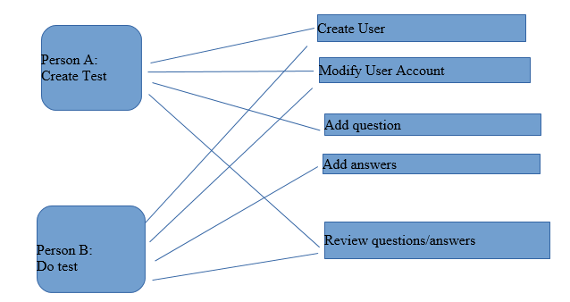

**Significant Use Case Descriptions**

1. Create User

This use case occurs when an administrator wishes to add a new user account.

1. Modify User Account

This use case occurs when an administrator wishes to change an existing user account.

1. Add questions

This use case occurs when a user wishes to create a new test.

1. Add answers

This use case occurs when a user wishes to make a multichoice answers.

1. Review questions/answers

This use case occurs when a user wishes to review their test.

# **4. Logical View**

This application uses Open Source components. You can find these projects below.

* [Ruby on Rails](https://github.com/rails/rails)
* [jQuery](https://github.com/jquery/jquery)
* [Bootstrap](https://github.com/twbs/bootstrap-sass)
* [Devise](https://github.com/plataformatec/devise)
* [Ckeditor](https://github.com/galetahub/ckeditor)
* [Flipclock.js](http://flipclockjs.com/)
* [Clipboard.js](https://github.com/zenorocha/clipboard.js/)

Database: Postgres

# **5. Processes View**

# **6. Deployment View**

This program is deployed and run by any devices with internet connection.

This project is a website that allows users to create multichoice tests and share them. [http://agile-hollows-29849.herokuapp.com](http://agile-hollows-29849.herokuapp.com/)

# **7. Size and Performance**

Volumes

* Simultaneous users 30 max

Performance

* With maximum load all transactions well under standard server script / database connection timeout – 20 seconds.

# **8. Quality**

Using Chrome or Firefox to get best performance.

This system is supported by many operating system.

Contents

**1. Introduction** 2

1.1 Purpose of the Document 2

1.2 Scope 2

1.3 Definitions, Acronyms, and Abbreviations 2

1.4 References 2

**2. Architectural Goals and Constraints** 2

**3. Use – Case View** 2

**4. Logical View** 3

**5. Processes View** 3

**6. Deployment View** 4

**7. Size and Performance** 4

**8. Quality** 4